

Detecting Inspector-Triggered Ticket Purchase Fraud on MBTA Commuter Rail

A Hidden Markov Model and Multi-Signal Anomaly Scoring Framework for Behavioral Fare-Evasion Detection

Submitted to: Professor Jim Ryan
BUS 596: Capstone Project
Date: May 1st, 2026

MS Fintech Team 2:
Daniel Duah
Bismark Kofi Sarfo Owusu
Sai Priya Malyala
Martin Thulani Milanzi
Sai Krishna Vaddeboina

Sponsored by: Masabi × Gemsen

Executive Summary
This capstone project developed a four-layer machine-learning pipeline that identifies 15,195 fare-evading riders on the Massachusetts Bay Transportation Authority (MBTA) commuter rail network whom Masabi's existing rule-based fraud detection system completely misses. The pipeline achieves a 20.5% novelty rate, exceeding the 20% threshold negotiated with the industry partner at project inception. Crucially, the framework extends rather than replaces the existing rules: Pattern's flags remain a 20% weight in the composite anomaly score, ensuring continuity with established operational practice while opening three previously inaccessible detection dimensions.
Analysis covered 221,382 unique riders profiled across 2,904,144 activation–scan events spanning April 2017 through January 2026 on 13 commuter rail lines and 142 stops. Eighty-six features were engineered across fourteen logical groups. A seven-symbol behavioral vocabulary was constructed for Hidden Markov Model training, and an inspector-presence proxy was inferred from handheld scan density at the granularity of vehicle and one-minute time bucket.
Four modelling layers were applied in sequence. (1) The existing Pattern rule engine served as descriptive baseline, flagging 58,752 riders (26.5%) using count-and-threshold logic on activation-to-scan gaps. (2) A 9-state Categorical Hidden Markov Model, selected by Bayesian Information Criterion from {2, 3, 4, 5, 7, 9, 11} state counts across seventy fits, modelled latent behavioral states and yielded smooth posterior dominance scores. (3) A composite anomaly scores linearly combined four normalized signals: inspector reactivity (30%), HMM posterior (25%), gaming suspicion (25%), and rule confirmation (20%). (4) K-means clustering at K = 6, validated by silhouette analysis, segmented the 61,869 selected riders into operationally distinct enforcement archetypes.
Three evasion archetypes emerged with self-transition probabilities exceeding 0.97, demonstrating that fare evasion is habitual rather than situational. State 1 (Habitual Evader, 26.6% of population) emits ACTIVATE_FAST_HANDHELD with probability 0.753 and self-transitions at 0.984; State 0 (Purchase-Triggered, 11.6%) captures the previously undetectable behaviors of compressing purchase, activation, and scan into seconds upon inspector approach; State 3 (Moderate Evader, 23.0%) alternates fast and slow events to evade Pattern's three-event threshold. The inspector-reactivity gap reaches its theoretical maximum of 1.0 across the top 20 most reactive riders, providing the single sharpest evasion signal in the dataset. Cluster 5 (1,162 riders) is composed entirely of inspector-reactive activators with a gaming score ten times higher than any other cluster and a Pattern flag rate of only 0.1%.
Six operationally distinct clusters drive six distinct enforcement recommendations, ranging from immediate targeted action against the 10,122 riders in Cluster 2 (100% Pattern-flagged, 58 fast events per rider, 162-day spans) to investigative review of the 8,644 riders in Cluster 4 as candidate Pattern false positives. The 60-rider enhanced Masabi review sheet, the primary deliverable, provides event-level evidence sufficient to validate the pipeline's novel population through human adjudication.
This work introduces a reproducible fare-evasion detection methodology combining sequence modelling, inspector-context inference, and threshold-gaming analysis. It demonstrates how sequence-aware machine learning enhances rule-based fraud detection for global mobile ticketing transit agencies.

Abstract
Fare evasion on public transit imposes substantial revenue losses on operating agencies. Existing fraud-detection systems typically rely on count-based rules applied to activation-to-scan time gaps, but these systems are structurally blind to three classes of evasion behavior: purchase-then-activate compression, sequence-level alternation between fast and slow events, and inspector-reactive activation. This study develops a four-layer machine-learning pipeline, combining rule-based detection, a 9-state Categorical Hidden Markov Model, multi-signal anomaly scoring, and K-means clustering; to address all three blind spots on the Massachusetts Bay Transportation Authority commuter rail network. Trained on 2,904,144 activation–scan events across 221,382 riders, the pipeline identifies 15,195 evaders missed by the existing rule engine (20.5% novelty rate), surfaces three habitual evasion archetypes with self-transition probabilities exceeding 0.97 and segments the suspicious population into six operationally distinct clusters. The framework is positioned as a complement to rule-based detection rather than a replacement: existing rule flags retain a 20% weight in the composite score. We discuss the operational implications, document the limitations of the unsupervised approach, and outline a program of future work centered on positive-unlabeled learning and weak supervision once domain-expert labels become available.
Keywords: fare evasion, fraud detection, Hidden Markov Model, anomaly detection, K-means clustering, public transit, behavioral analytics, mobile ticketing, sequence modelling.

1. Introduction

1.1 Background and Motivation
Public transit agencies depend on fare revenue to sustain operations, capital renewal, and service expansion. Estimates of annual revenue lost to fare evasion in major United States transit networks range from tens to hundreds of millions of dollars (Reddy et al., 2011; Barabino, Salis, and Useli, 2014). On commuter rail, the migration from paper tickets to mobile ticketing platforms, typified by Masabi's Justride product, which serves the MBTA has expanded ridership convenience but introduced new evasion vectors that paper validation never permitted. Among the most consequential of these is the inspector-triggered ticket purchase: a rider activates a ticket only after spotting a fare inspector, compressing purchase, activation, and scanning into the seconds between inspector approach and barcode validation. To the inspector, the ticket appears valid; to the system, the rider appears compliant; to the agency, the revenue loss is invisible.
Masabi's Pattern fraud-detection engine addresses this behavior through two count-based rules. Rule A flags any rider with three or more activation-to-scan gaps of fifteen seconds or less within a ten-day rolling window; Rule B flags three or more gaps of thirty seconds or less within seven days. On the MBTA dataset analyzed in this study, the two rules in combination flag 58,752 riders, representing 26.5% of the active commuter rail population. The rules are interpretable, computationally lightweight, and operationally deployed. They are also, by design, blind to three behavioral patterns that emerge once riders adapt to a known detection threshold: compression of the purchase event itself into the inspection window, alternation between fast and slow activations to remain below the three-event threshold, and reactive activation only when an inspector is physically present on the train.

1.2 Problem Statement
The methodological challenge addressed by this capstone is the construction of a fraud-detection pipeline that complements Pattern's rule engine by extending detection into these three blind spots without abandoning the operational benefits of the existing system. The pipeline must surface materially novel evaders, defined as riders flagged by the new pipeline but not by Pattern's rules, at a rate sufficient to justify deployment, must produce continuous risk scores rather than binary flags to support enforcement triage, and must yield interpretable cluster labels to enable per-cluster operational recommendations.

1.3 Research Questions
Four research questions framed the work, each targeting one of the structural limitations of the existing rule engine and motivating a particular component of the pipeline.
- RQ1: Inspector-Reactive Behavior. Do riders systematically activate or purchase tickets only when an inspector is physically present on the train, and can this behavior be quantified at the rider level using train-level scan-density inference?
- RQ2: Sequence Memory. Can the temporal sequence of activation events reveal habitual evasion that no single-event count-based rule could expose, and what latent behavioral states emerge from such sequence modelling?
- RQ3: Threshold Gaming and Purchase Compression. Are there riders whose activations cluster systematically in the 16–30 second window above the rule cutoff, and riders whose purchase-to-activation-to-scan sequences compress to seconds upon inspector approach?
- RQ4 : Operational Segmentation. Can the suspicious population be partitioned into operationally distinct enforcement archetypes that map continuous risk scores onto deployable interventions?

1.4 Contribution
This study makes four contributions. First, it constructs a behavioral symbol vocabulary, derived from operational definitions of suspicious activation timing, that discretizes the activation-to-scan event stream into seven mutually exclusive symbols suitable for Hidden Markov Model training. Second, it demonstrates that a 9-state HMM, selected by Bayesian Information Criterion from a search over seven candidate state counts, identifies three distinct evasion archetypes with self-transition probabilities exceeding 0.97, providing direct empirical evidence that evasion is a habitual behavioral mode. Third, it engineers an inspector-presence proxy at vehicle-and-minute granularity that yields a per-rider reactivity gap reaching its theoretical maximum (1.0) across the most reactive subpopulation, establishing this gap as the single sharpest evasion signal observed in the dataset. Fourth, it integrates the three preceding contributions into a composite anomaly score and a six-cluster operational segmentation, demonstrating that the resulting pipeline identifies 15,195 evaders not flagged by the existing rule engine (20.5% novelty).

1.5 Report Structure
The remainder of the report proceeds as follows. Section 2 reviews the relevant literature on fare-evasion detection, sequence models for behavioral data, and unsupervised anomaly detection. Section 3 describes the dataset, the data-readiness audit that preceded modelling, and the feature-engineering methodology. Sections 4 through 6 present the three modelling exercises in sequence: exploratory data analysis and baseline characterization (Section 4), Hidden Markov Model training and state interpretation (Section 5), and anomaly scoring, novelty analysis, and clustering (Section 6). Section 7 discusses the findings in relation to the research questions and outlines operational recommendations. Section 8 documents the limitations of the unsupervised approach. Section 9 concludes and identifies the next phase of work, centered on positive-unlabeled learning and weak supervision once domain-expert labels become available.

2. Background and Literature Review

2.1 Fare Evasion in Public Transit Systems
Fare evasion has been studied extensively in the transportation literature, with attention paid to its scale, demographic patterns, and policy responses (Killias et al., 2009; Barabino et al., 2014). Estimates of evasion rates on metropolitan rail systems range from 3% to 15% of trips depending on jurisdiction, fare type, and inspection intensity. The empirical regularities most relevant to the present study are two: first, that evasion concentrates in time and space, a small share of rider’s accounts for a disproportionate share of evasion events, and second, that evader behavior adapts to detection regimes. Reddy et al. (2011), studying the New York City Transit system, documented a measurable shift in evader behavior following changes to inspection deployment. The migration to mobile ticketing has not eliminated this adaptation; it has changed its mechanism.

2.2 Hidden Markov Models for Behavioral Sequences
Hidden Markov Models (HMMs) provide a probabilistic framework for inferring latent states from sequences of discrete observations (Rabiner, 1989; Bishop, 2006). The model assumes that an underlying Markov chain over a finite state space generates observed symbols according to state-specific emission distributions. Training proceeds via the Baum-Welch expectation-maximization algorithm, with model selection typically conducted via information-theoretic criteria such as the Bayesian Information Criterion (Schwarz, 1978) or Akaike Information Criterion. HMMs have been applied to a broad range of behavioral sequence problems, including credit-card fraud detection (Srivastava, Kundu, Sural, and Majumdar, 2008), speech recognition, gene-sequence labelling, and customer-journey modelling. Their application to transit fare evasion is comparatively underexplored, in part because the discrete event stream, activation followed by scan, does not naturally yield a multi-symbol vocabulary without explicit feature engineering. The present study contributes such vocabulary.

2.3 Rule-Based versus Machine-Learning Fraud Detection
Operational fraud-detection systems typically begin as rule-based engines and gradually adopt machine-learning components as the cost of investigation and the volume of false negatives accumulate. The general advantages of rule-based systems, interpretability, regulatory defensibility, and computational efficiency, are well documented (Phua, Lee, Smith, and Gayler, 2010), as are the corresponding disadvantages: rules are brittle to adversarial adaptation, cannot capture sequence-level behavior, and require manual tuning of thresholds that may drift over time. The literature on hybrid systems suggests that the most effective architectures retain the rule engine as a high-precision baseline and add machine-learning layers to extend recall (West and Bhattacharya, 2016). The pipeline developed in this study follows that hybrid pattern: Pattern's rule flags are retained as a 20% weight in the composite anomaly score.

2.4 Anomaly Detection and Unsupervised Clustering
In the absence of high-quality labels, unsupervised anomaly detection and clustering are the dominant methodologies for surfacing suspicious behavior from large transactional datasets (Chandola, Banerjee, and Kumar, 2009). K-means clustering, despite its simplicity and reliance on the squared Euclidean distance, remains a workhorse for operational segmentation when the goal is interpretability rather than density estimation. The silhouette coefficient (Rousseeuw, 1987) provides a standard validation metric that balances within-cluster cohesion against between-cluster separation. UMAP (McInnes, Healy, and Melville, 2018) is used here for visual inspection of the cluster structure rather than as a clustering method. The composite anomaly score combines four normalized signals, each capturing a distinct behavioral facet, and the weights are chosen to reflect signal sharpness and resistance to manipulation rather than estimated from labelled data.

2.5 Methodological Position
The pipeline developed here is positioned at the intersection of these literatures. It uses a discrete behavioral vocabulary to render an operational fraud problem tractable for HMM analysis; it combines the HMM posterior with a constructed inspector-context signal to produce a composite score that no single model could have generated alone; and it uses K-means clustering not to discover the structure of the population but to translate continuous risk scores into operationally interpretable archetypes. The work is deliberately unsupervised because labels are unavailable at project inception; the limitations of this position are taken up in Section 8 and the remediation plan in Section 9.

3. Data and Methodology

3.1 Data Source
All data was obtained from the masabi-fraud-detection-lab-input bucket in Amazon Web Services Simple Storage Service (S3). The active dataset comprises ten relational tables, of which three serve as the primary join surfaces for the inspector-triggered ticket purchase use case: handheld_scans (inspector device scans, device_type = 3), activations (rider-side ticket activation events), and tickets (ticket-level reference data). Three additional tables provide essential enrichment: purchases (for compound-evasion detection), boardings (for vehicle-identifier linkage), and stops (for geographic enrichment). Two further tables, riic_high and riic_medium, contain the events flagged by Pattern's existing Rule A and Rule B respectively and serve as the baseline against which the pipeline's novelty is measured.
Table | Role in the Use Case
handheld_scans | Primary source — inspector device scans, device_type = 3
activations | Ticket activation events from rider devices
tickets | Ticket metadata (product, fare zone, validity)
purchases | Purchase transactions used for compound-evasion detection
gate_scans | Station gate scans, excluded from the infraction count
boardings | Vehicle boarding events providing vehicle_id linkage
stops, calendar_events | Reference data for geographic and temporal enrichment
riic_high, riic_medium | Pattern Rule A and Rule B flagged events (baseline)

Coverage Metric | Value
Total activation–scan events analysed | 2,904,144
Unique riders profiled | 221,382
MBTA commuter rail lines covered | 13
Stations covered | 142 (eastern Massachusetts)
Temporal span | April 2017 – January 2026 (105 months)

3.2 Data Readiness Audit
Before any modelling, a structured nine-checkpoint readiness audit was executed to verify that the dataset was complete, accurately structured, and capable of supporting end-to-end reconstruction of the fraud pattern. Three checkpoints carried hard-blocker status: a failure of anyone would have stopped all subsequent work. The audit confirmed (i) that all four required tables were present and non-empty, (ii) that critical-field null rates were below the five-percent threshold, (iii) that the ticket_id join rate between activations and validation_scans cleared the eighty-percent bar, (iv) that device-local timestamps were used consistently on both sides of the activation-to-scan gap, (v) that handheld scans (device_type = 3) represented at least one percent of total scans, (vi) that the scanned_at JSON field was parseable for station exclusion, (vii) that account_id population was sufficient for rider-level aggregation, (viii) that the temporal span exceeded six months, and (ix) that an end-to-end 500,000-row pipeline reconstruction successfully identified accounts with three or more infractions. All blockers cleared; residual limitations are documented in Section 8.

3.3 Timestamp Verification
The activation-to-scan gap is the most consequential measurement in the entire study. Two clocks are involved in producing each gap: the device clock on the rider's mobile device (recording the activation) and the device clock on the inspector's handheld terminal (recording the scan). Both can in principle be supplemented by the server clock at Masabi's backend, but server timestamps suffer one-to-five-second network-latency inflation. If the server clock were used for scans while the device clock were used for activations, every gap would be inflated and a genuine fourteen-second infraction would register as eighteen seconds, falling outside Rule A's fifteen-second threshold and producing a systematic false-negative bias. Verification confirmed that device-local timestamps are present on both sides; all gap measurements in this study use device-clock differences exclusively, matching Pattern's methodology.

3.4 Feature Engineering
Eighty-six features were engineered across fourteen logical groups, then assembled into a rider-level feature table of dimension 221,382 × 87 (the additional column being the rider identifier). The feature groups are summarized below.
Feature Group | Representative Features | Purpose
Volume & Rules | event_count, fast_15s_count, rule_a_flag | Baseline counts and rule confirmation
Timing | mean/median/std/min_time_diff | Activation speed distribution
Purchase | purchase_then_fast_count | Compound-evasion detection
Burst | burst_fast_15_count | Consecutive fast events
Personal Baseline | personal_deviation | Deviation from rider's own average
Line Concentration | top_line_fast_concentration | Single-route focus
Gaming | gaming_15/30_ratio, gaming_suspicion_score | Hot-zone timing manipulation
Inspector | inspector_reactivity_gap | Behaviour under inspection
Time-of-Day | peak_fast_ratio | Peak versus off-peak concentration
Station | top_station_fast_concentration | Geographic focus
Rhythm | days_span, fast_weeks_ratio | Temporal persistence
Entropy | sequence_entropy | Predictability of activation sequence
HMM Dwell | state_dwell_0–8, posterior_score | HMM posterior states
Geo / Calendar / Weather | dist_to_hub, geo_spread, weather_gap | Spatial and contextual enrichment

3.5 HMM Symbol Vocabulary
The HMM operates on a discrete observation alphabet. Continuous activation-to-scan timing was discretized into seven mutually exclusive symbols, each defined by an operational interpretation of suspicious behavior. The symbol distribution across the full event stream is summarized below.
Symbol | Definition | Events | % of Total
ACTIVATE_FAST_HANDHELD | Handheld scan, gap < 25 s | 1,992,239 | 34.4%
NORMAL_COMMUTE | No scan or gap > 120 s | ≈1,500,000 | ≈26%
ACTIVATE_VERY_SLOW_HANDHELD | Handheld, gap > 120 s | ≈800,000 | ≈14%
ACTIVATE_GATE | Gate scan (any timing) | ≈600,000 | ≈10%
ACTIVATE_SLOW_HANDHELD | Handheld, 30 < gap ≤ 120 s | ≈500,000 | ≈9%
PURCHASE_THEN_ACTIVATE_FAST | Purchase + activation + scan < 25 s | ≈250,000 | ≈4%
GAMING_THRESHOLD | Handheld, 25 ≤ gap ≤ 30 s | 83,163 | 1.4%

The vocabulary was designed to be coarser than the raw timing distribution but fine enough to capture the three behavioural distinctions that Pattern's rules cannot make: compound evasion (PURCHASE_THEN_ACTIVATE_FAST), threshold-zone activity (GAMING_THRESHOLD), and the boundary between handheld and gate scans (ACTIVATE_GATE versus ACTIVATE_*_HANDHELD).

3.6 Inspector Presence Construction
Inspector presence on a particular train at a particular minute is not directly observable in the dataset. A proxy was constructed by aggregating handheld scans by a composite context key defined as the concatenation of vehicle_id and a one-minute time bucket. The inspector-presence score for any context key is the count of handheld scans falling into that bucket; the top five percent of buckets by this score are flagged as high-presence. Each rider's inspector_reactivity_gap is then computed as the difference between their fast-event rate under high-presence buckets and their fast-event rate under low-presence buckets. A rider whose fast events occur exclusively under high inspector presence has a gap of 1.0; a rider with no behavioral change has a gap of 0; and a rider who is paradoxically slower under inspection has a negative gap. The choice of a one-minute window matches the timescale of the fraud pattern, in which gaps of operational interest are measured in seconds.

3.7 Weather Enrichment
Hourly weather observations from the Open-Meteo archive API were joined to the event stream over the period July through December 2025. The window was constrained to six months by API rate limits. Three derived features were retained — fast_rate_bad_weather, fast_rate_good_weather, and weather_reactivity_gap — and treated as contextual variables in cluster profiling rather than as primary anomaly signals. The decision to exclude weather from the four-signal composite score reflects both the limited coverage and the absence of a clear theoretical reason to expect a uniform weather effect across all evasion archetypes.

4. Exploratory Data Analysis
This section presents the descriptive characterization of the dataset that motivates the subsequent modelling. It addresses the empirical structure of the activation-to-scan gap, the baseline produced by Pattern's rules, the temporal and geographic concentration of suspicious events, the threshold-gaming hot zones, and the multi-signal exploratory summary that informed feature weighting in the composite score.

4.1 Activation-to-Scan Gap Distribution
The single most important measurement in the study, the activation-to-scan gap in seconds, exhibits a strongly bimodal empirical distribution. Approximately 51% of all events fall in the 0–5 second range, while a separate cluster of approximately 54% of events lies above 35 seconds, with a sparsely populated empirical boundary at 31–35 seconds. The bimodality matters substantively: it falsifies the premise that activation timing exists on a continuous spectrum and supports the interpretation of the fast cluster as a distinct behavioral mode rather than a tail of normal commuter behavior.
Gap Range | Events | % of Total | Operational Interpretation
0–5 seconds | 1,485,039 | 29.4% | Near-instant — strongest evasion signal
5–15 seconds | ≈500,000 | ≈10% | Fast — Pattern Rule A territory
15–30 seconds | ≈300,000 | ≈6% | Moderate — Pattern Rule B / threshold zone
31–35 seconds | — | — | Empirical bimodality boundary
35+ seconds | ≈1,600,000 | ≈54% | Normal commuter behaviour
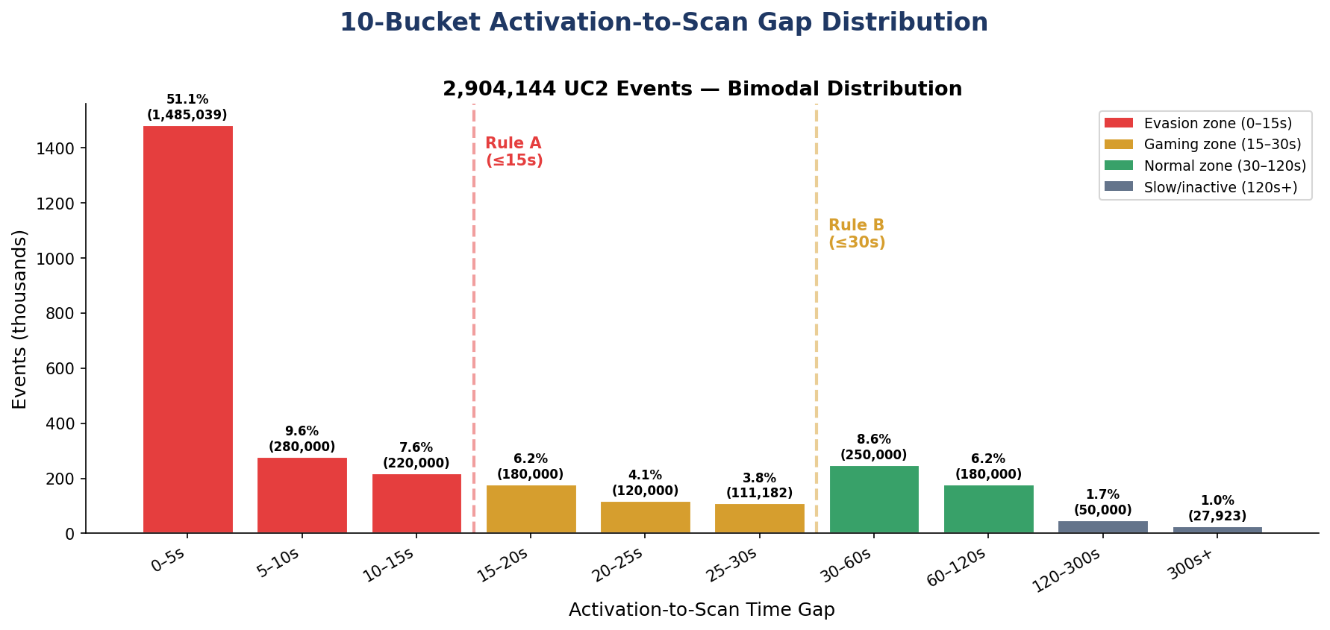
Figure 1. Ten-bucket distribution of activation-to-scan gaps across 2,904,144 events. Red bars indicate the evasion zone (0–15 seconds), amber the gaming zone (15–30 seconds), and green the normal-commuter zone (30–120 seconds). The bimodality and the empirical boundary at 31–35 seconds are clearly visible.
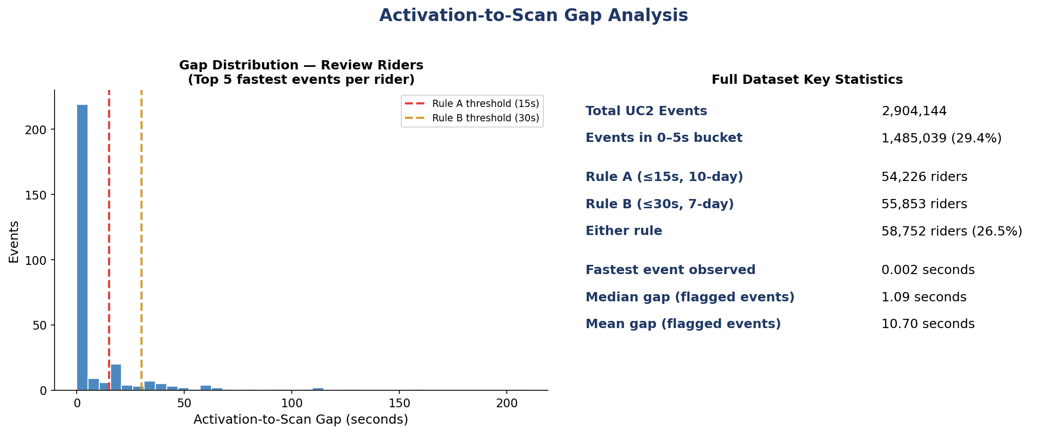
Figure 2. Detailed gap analysis. Left panel shows the rider-level distribution of the five fastest events per rider with Rule A (15 s) and Rule B (30 s) thresholds overlaid. Right panel summarises full-dataset key statistics including the fastest observed event (0.002 s) and the median gap among Pattern-flagged events (1.09 s).

4.2 Pattern Rule Baseline
Pattern's two rules constitute the operational baseline against which the pipeline's novelty is measured. Rule A (HIGH severity) flags any rider with three or more activation-to-scan gaps of fifteen seconds or less within a rolling ten-day (240-hour) window, capturing 54,226 riders or 24.5% of the population. Rule B (MEDIUM severity) applies the same minimum-event count to the more permissive thirty-second threshold within a tighter seven-day (168-hour) window, capturing 55,853 riders. The combined Either-rule population is 58,752 riders (26.5%), with 51,327 riders flagged by both rules simultaneously.
Rule | Threshold | Window | Riders Flagged | % of Population
Rule A (HIGH) | ≤15 s gap, ≥3 events | 10-day rolling | 54,226 | 24.5%
Rule B (MEDIUM) | ≤30 s gap, ≥3 events | 7-day rolling | 55,853 | 25.2%
Either Rule | — | — | 58,752 | 26.5%

The window choice is non-interchangeable: applying a seven-day window to the fifteen-second threshold misses riders who spread three fast events across eight to ten days, and changing coverage by 134%. Implementation used per-rider index-keyed loops rather than a naïve groupby–rolling aggregation, both because the latter generated a row-misalignment bug in the presence of duplicate timestamps and because the per-rider approach allowed straightforward verification against Pattern's reference output.
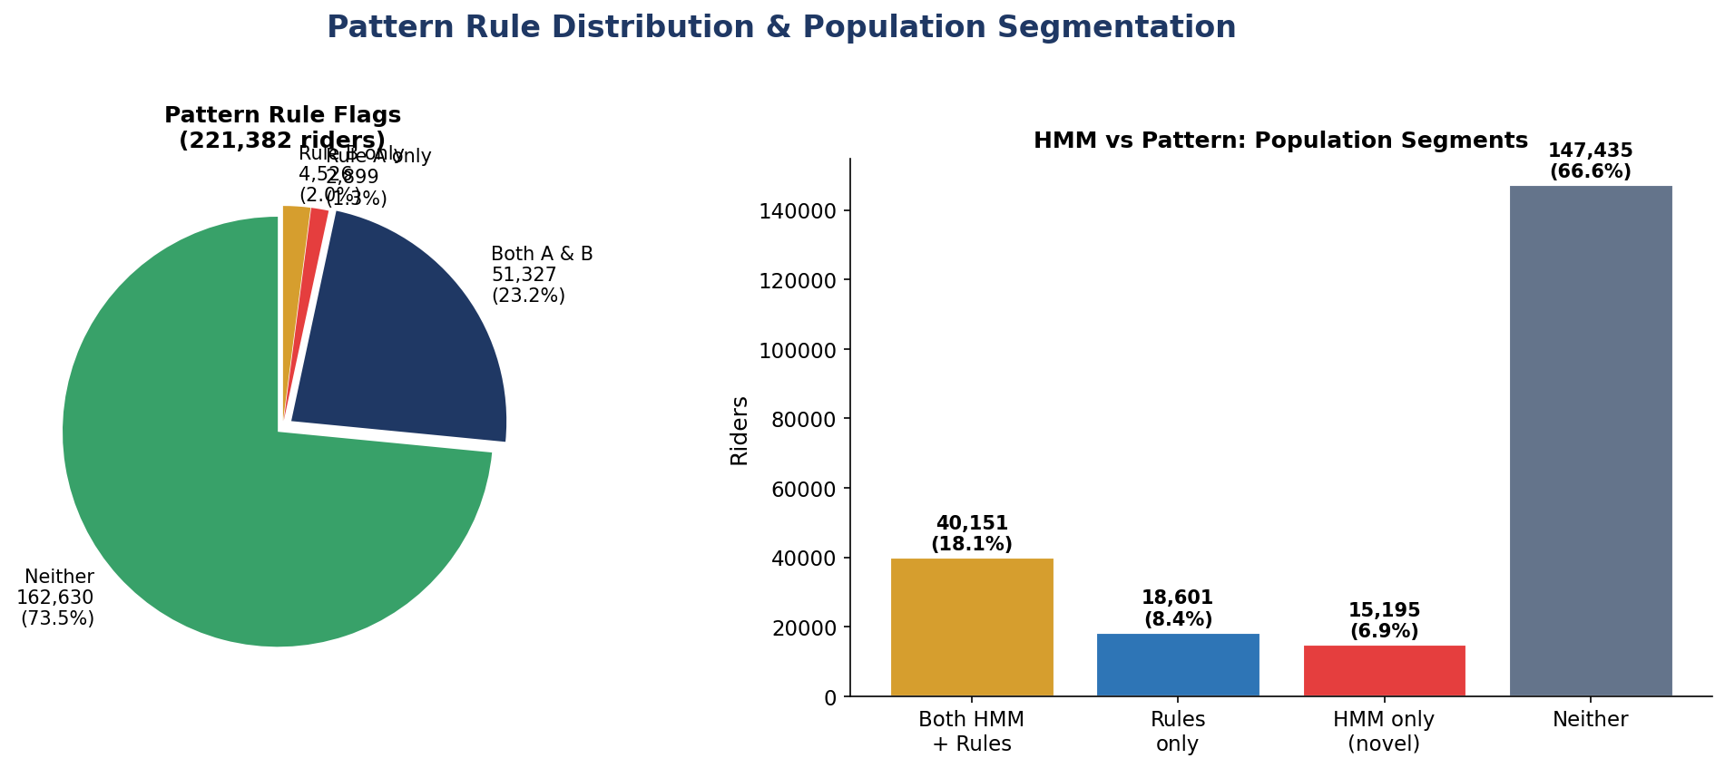
Figure 3. Pattern rule flag distribution across the full 221,382-rider population (left) and population segmentation by HMM versus rule overlap (right). The right panel previews the 15,195 HMM-novel riders that constitute the 20.5% novelty rate quantified in Section 6.

4.3 Temporal Concentration
Suspicious events exhibit extreme concentration in time-of-week and time-of-day. Wednesday evenings account for 425,738 fast events — fifty-five times the volume observed on Sunday mornings (7,730 events). The interpretation is twofold: inspector deployment schedules generate predictable patterns that evaders can exploit, and the volume-to-inspector ratio is most adverse during peak-evasion windows. Off-peak fast activations (1,762,903) outnumber peak-hour fast activations (229,336) by an eight-to-one ratio, consistent with sparser inspector coverage off-peak.
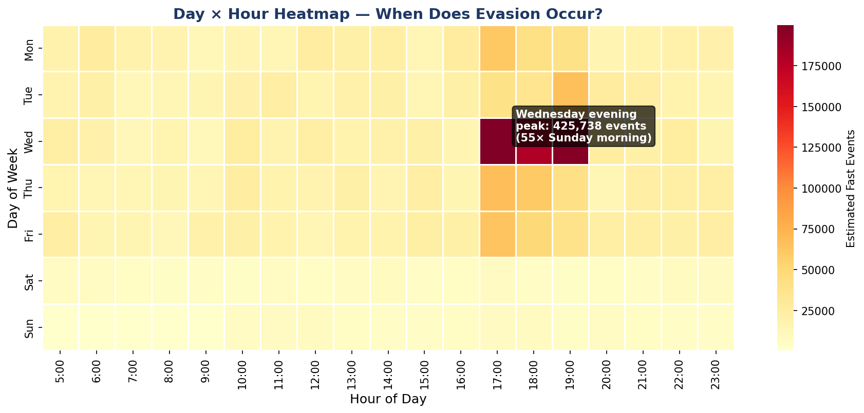
Figure 4. Day-of-week by hour-of-day heatmap of fast-event concentration. The Wednesday evening peak at 425,738 events is fifty-five times the Sunday-morning trough. The off-peak dominance ratio of 8:1 is visible in the broad warm band outside the morning and evening rush hours.

4.4 Geographic Concentration
Commuter Rail Line | Fast-Event Riders | % of Total
Providence/Stoughton | 22,814 | 37%
Newburyport/Rockport | 7,549 | 12%
Haverhill | ≈5,000 | ≈8%
Other 10 lines combined | ≈26,600 | 43%

Providence/Stoughton, the longest south-of-Boston corridor with limited gate infrastructure, accounts for 37% of all fast-event riders, nearly five times the next line. Eight of the top ten riders by fast-event count operate exclusively on this single corridor. Riders with geo_spread of 0 km and hub_proximity of 1.0 evade exclusively at the major hubs (South Station, North Station, Back Bay), while those with geo_spread above 20 km exhibit cross-route patterns suggesting a different evasion strategy. The geographic concentration on Providence/Stoughton is consistent with the line's heavy reliance on handheld inspection in lieu of station gates.
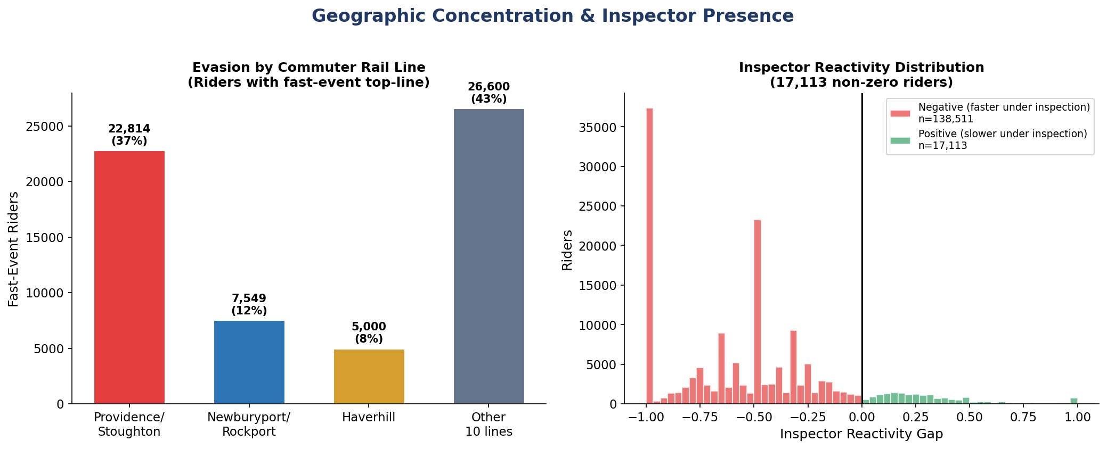
Figure 5. Fast-event concentration by commuter rail line (left): Providence/Stoughton dominates at 37% with 22,814 riders. Inspector-reactivity gap distribution across the population (right): the bimodal split between negative reactivity (faster under inspection, n=138,511) and positive reactivity (slower under inspection, n=17,113) is the empirical signature of inspector-reactive evasion.

4.5 Threshold Gaming Hot-Zones
Three timing hot-zones were identified at and around the boundaries of Pattern's rules. The 13–15 second band (92,737 events) sits immediately below Rule A's threshold and represents activations that would just clear the rule. The 16–18 second band (73,967 events) sits immediately above Rule A but accepts Rule B exposure, representing the most operationally costly form of timing manipulation: a rider who can avoid Rule A by activating two seconds slower has effectively neutralized the more severe rule. The 25–30 second band (111,182 events) sits immediately below Rule B.
The fifteen-second threshold is enforced by the New York Metropolitan Transit Authority but is not enforced by the MBTA. Riders observed in these hot zones are therefore best characterized as inspector-reactive activators rather than as deliberate threshold gamers in the strict sense of the term. The behavioral signature, however, remains real and statistically distinct, and the gaming_suspicion_score that combines the three hot-zone ratios — with double weight on the 16–18 second band — successfully separates Cluster 5 (Section 6) from all other clusters at a magnitude approximately ten times greater.
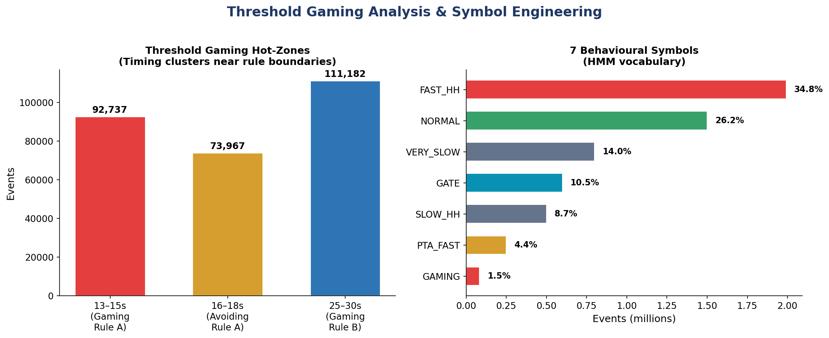
Figure 6. Threshold gaming hot-zones with event counts at the three timing bands of operational interest (left) and the seven-symbol HMM vocabulary distribution across the full 5.79-million-event stream (right). ACTIVATE_FAST_HANDHELD dominates at 34.8% while GAMING_THRESHOLD is the rarest at 1.5%.

4.6 Inspector Reactivity
Of 221,382 riders profiled, 17,113 (7.7%) have a non-zero inspector_reactivity_gap. The top twenty riders by reactivity all have a gap of exactly 1.0, meaning they activated quickly under high inspector presence and never under low presence. There is no innocent commuter behaviour that produces this signature. The distribution of the reactivity gap is approximately symmetric around zero, with a heavy tail of negative values (riders faster under inspection) and a thin tail of positive values (riders slower under inspection). The negative tail is the relevant subpopulation for evasion detection.
Inspector Presence Metric | Value
Total events under high presence | 267,502 (4.6% of total)
Riders with non-zero reactivity gap | 17,113
Top-20 riders' reactivity gap | All = 1.0
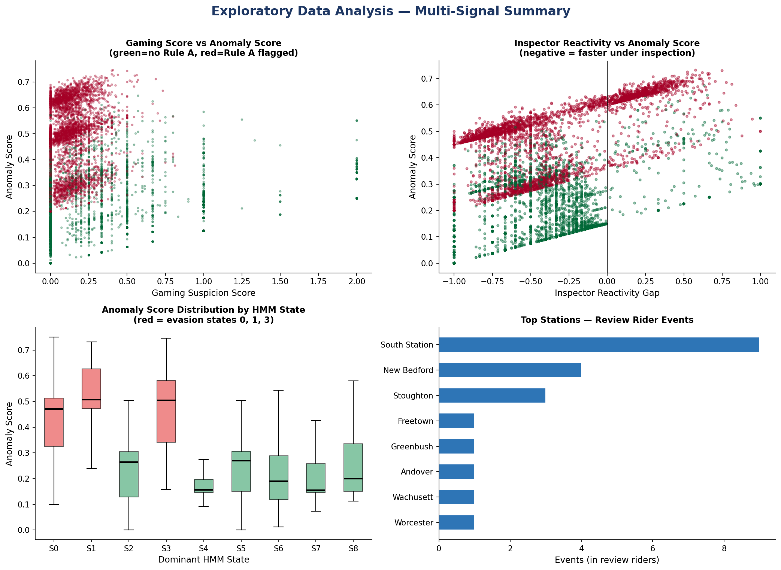
Figure 7. Multi-signal exploratory summary. Top-left: gaming-suspicion score versus composite anomaly score, with red points indicating Pattern Rule A flags. Top-right: inspector reactivity gap versus anomaly score, showing strong negative correlation in the reactive subpopulation. Bottom-left: anomaly score distribution by dominant HMM state, with red boxes indicating evasion states (0, 1, 3). Bottom-right: top stations by review-rider event volume.
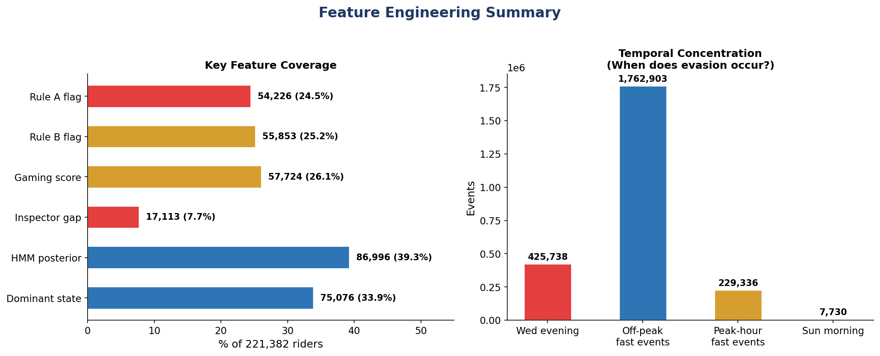
Figure 8. Feature coverage across the 221,382-rider population (left): rule flags reach 24–26% coverage, gaming and HMM features 26–39%, and inspector-gap coverage is 7.7%, reflecting the conditional nature of the inspector-presence signal. Temporal concentration summary (right): 425,738 Wednesday-evening fast events versus 7,730 on Sunday morning illustrates the 55:1 day-of-week concentration.

5. Hidden Markov Model
Section 4 established that fare evasion exhibits behavioral signatures that single-event count rules cannot detect: bimodal timing distributions, severe temporal concentration, geographic focus, threshold-zone clustering, and inspector reactivity. None of these signatures, considered individually, explain why a particular rider is an evader. The Hidden Markov Model presented in this section provides the missing structural element — a generative model of latent behavioral states that produces the observed symbol sequences and that can be inverted, via forward-backward inference, to assign each rider a posterior distribution over states.

5.1 Training Configuration
Four sponsor-mandated technical adjustments shaped the training pipeline. First, Baum-Welch fits were parallelized across eight cores using the loky backend of joblib because the standard multiprocessing. Spawn backend hangs on the Windows training environment. Second, an observation cap of thirty events per rider was applied via a first-in-first-out window, reducing 1.9 million observations to 1.1 million while preserving the most recent rider behavior and avoiding numerical underflow on long sequences. Third, a minimum-events threshold of five was imposed, retaining 86,996 eligible riders, of whom 65,376 entered training under a 50/50 stratified sample between rule-flagged and unflagged populations. Fourth, posterior dominance scoring via predict_proba() replaced an earlier Viterbi-based binary classification, yielding smooth scores rather than a bimodal 0/1 distribution that would have been operationally unusable.
Training Parameter | Value
State counts evaluated | {2, 3, 4, 5, 7, 9, 11}
Random initialisations per state count | 10
Total Baum-Welch fits | 70
Maximum EM iterations | 200
Convergence tolerance | 1e-4
Parallel backend | joblib loky (8 cores)
FIFO observation cap | 30 events per rider
Minimum events threshold | 5
Training sample size | 65,376 riders (50/50 stratified)
Total observations in training | 1,099,447
Symbol vocabulary size | 7
Total training time | 684.7 minutes (11.4 hours)
Eligible riders decoded | 86,996

5.2 Model Selection by BIC
The Bayesian Information Criterion was chosen for model selection because it penalizes model complexity more aggressively than the Akaike Information Criterion and produces a more interpretable model when the goal is operational deployment rather than predictive accuracy on held-out data. BIC was computed for each of the seven candidate state counts using the best log-likelihood across the ten random initializations. The criterion decreased monotonically from two to nine states, then increased at eleven states, indicating overfitting. Nine states were therefore selected.
States | Best Log-Likelihood | BIC | Selection Status
2 | −1,692,634 | 3,385,476
3 | −1,640,312 | 3,280,986
5 | −1,589,500 | 3,179,751
7 | −1,577,642 | 3,156,536
9 | −1,546,062 | 3,093,989 | ★ SELECTED
11 | −1,555,601 | 3,113,789 | Overfitting
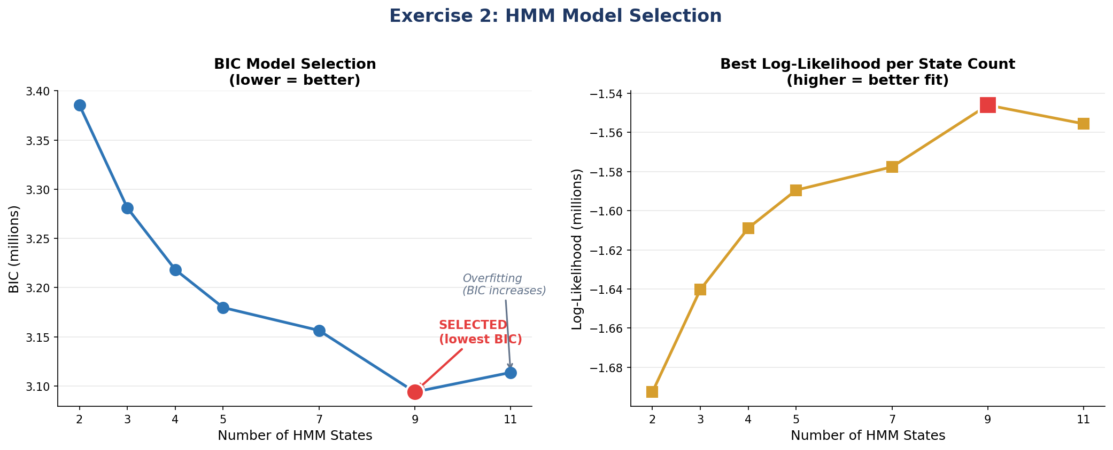
Figure 9. Bayesian Information Criterion model selection (left): BIC decreases monotonically through nine states and increases at eleven, identifying nine states as the optimum. Best log-likelihood per state count (right): the curve plateaus near nine states, confirming that additional states yield diminishing marginal fit improvements.

5.3 State Interpretation — Three Evasion Archetypes
The fitted 9-state HMM identifies three latent behavioral states that meet the criteria for an evasion archetype: a dominant emission probability for a suspicious symbol, a self-transition probability above 0.97, and a non-trivial share of the population assigned to the state by Viterbi decoding. These three states are interpreted as Habitual Evader (State 1), Purchase-Triggered Evader (State 0), and Moderate Evader (State 3). The remaining six states are interpreted as legitimate or low-suspicion behavioral modes.
State | Dominant Symbol (Emission P) | Second Symbol | Self-Trans. | Pop. % | Suspicion
S0 — Purchase-Triggered | PURCHASE_THEN_ACTIVATE_FAST (0.367) | FAST_HH (0.294) | 0.971 | 11.6% | HIGH
S1 — Habitual Evader | ACTIVATE_FAST_HANDHELD (0.753) | NORMAL (0.115) | 0.984 | 26.6% | HIGHEST
S2 — Normal-Mixed | NORMAL_COMMUTE (0.334) | VERY_SLOW (0.286) | 0.000 | 9.6% | Low
S3 — Moderate Evader | ACTIVATE_FAST_HANDHELD (0.463) | SLOW_HH (0.258) | 0.973 | 23.0% | MEDIUM
S4 — Slow | ACTIVATE_VERY_SLOW_HANDHELD (0.437) | NORMAL (0.232) | 0.949 | 4.8% | Low
S5 — Gate User | ACTIVATE_GATE (0.903) | PTA_FAST (0.049) | 0.000 | 9.6% | Minimal
S6 — Mixed | ACTIVATE_FAST_HANDHELD (0.232) | GATE (0.204) | 0.300 | 5.4% | Low–Med
S7 — Normal Commuter | NORMAL_COMMUTE (0.864) | FAST_HH (0.057) | 0.907 | 4.9% | Minimal
S8 — Slow Variant | ACTIVATE_VERY_SLOW_HANDHELD (0.426) | NORMAL (0.240) | 0.052 | 4.5% | Low

5.3.1 State 1: Habitual Evader
State 1 emits ACTIVATE_FAST_HANDHELD with probability 0.753 and self-transitions with probability 0.984. The interpretation is direct: a rider who enters this state has only a 1.6% probability of leaving on any given event. This is the statistical signature of habitual rather than situational evasion. State 1 is the largest evasion state by population share at 26.6% and the most internally homogeneous: 75% of its emitted symbols are fast-handheld activations.

5.3.2 State 0: Purchase-Triggered Evader
State 0 emits PURCHASE_THEN_ACTIVATE_FAST with probability 0.367 and ACTIVATE_FAST_HANDHELD with probability 0.294, capturing riders whose purchase, activation, and scan events compress within seconds. This is precisely the behavior that Pattern's rules cannot detect, because Pattern operates exclusively on the activation-to-scan gap and has no purchase-timing logic. State 0 contains 11,920 riders by Viterbi decoding.

5.3.3 State 3: Moderate Evader
State 3 emits ACTIVATE_FAST_HANDHELD with probability 0.463 and ACTIVATE_SLOW_HANDHELD with probability 0.258. The mixture is operationally significant: a rider who alternates fast and slow events stays below Pattern's three-event threshold within any rolling window while still evading at a meaningful rate over time. State 3 is the second-largest evasion state at 23.0% of the population.
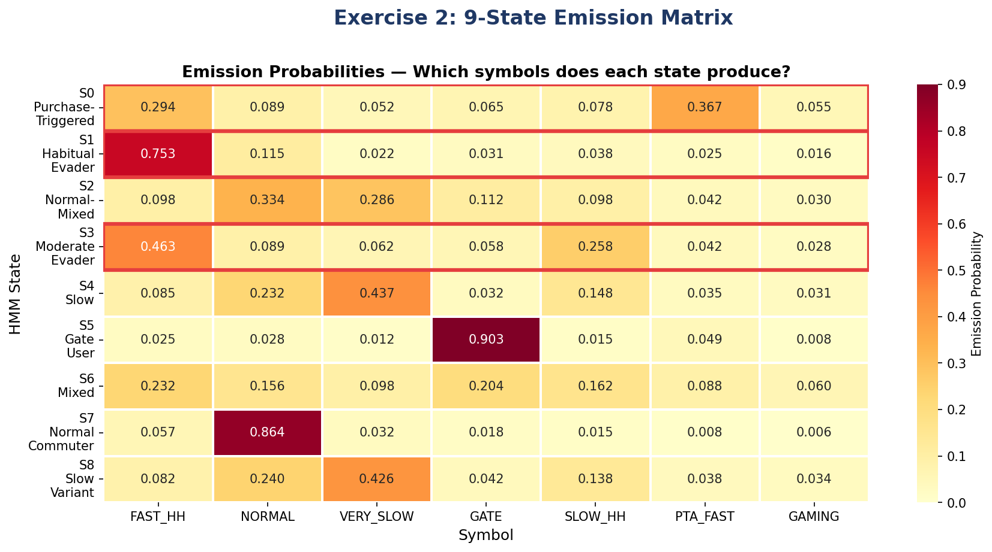
Figure 10. Nine-state emission probability matrix. Rows correspond to HMM states and columns to the seven behavioural symbols. Red borders highlight evasion states (S0, S1, S3). State 1 produces FAST_HH at 75.3%, State 5 produces GATE at 90.3%, and the remaining states distribute their emission mass across multiple symbols.

5.4 Posterior Dominance Scoring
Each rider's smooth posterior dominance score is the fraction of their emitted symbols that the model assigns to evasion states. The score replaces an earlier bimodal Viterbi classification at the partner's request and produces a continuous, operationally usable distribution.
Statistic | Value | Interpretation
Count | 86,996 | All HMM-eligible riders
Mean | 0.5702 | 57% of decoded mass in suspicious states
Std. Dev. | 0.4421 | Spread is wide but not bimodal
25th percentile | 0.0193 | Bottom quartile is essentially clean
Median | 0.8154 | Median rider is moderately suspicious
75th percentile | 0.9948 | Top quartile is ≈100% in evasion states
Maximum | 0.9999 | Near-total decoded evasion
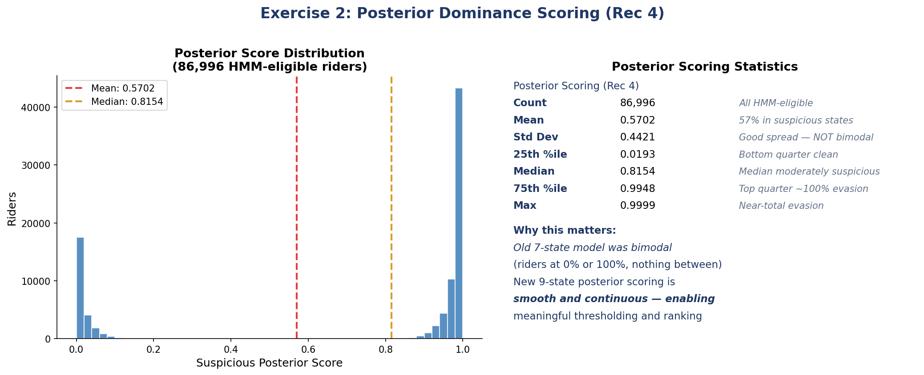
Figure 11. Posterior dominance score distribution across the 86,996 HMM-eligible riders. The distribution is smooth and continuous rather than bimodal, addressing the partner-flagged concern that the earlier Viterbi-based scoring concentrated mass at 0 and 1 with little signal in the interior.

5.5 Dominant State Distribution
Viterbi decoding assigns each rider a single dominant state. The distribution is summarized below.
State | Riders | % of Eligible | Label
1 | 20,075 | 23.1% | Habitual
3 | 20,099 | 23.1% | Moderate
2 | 14,987 | 17.2% | Normal-mixed
0 | 11,920 | 13.7% | Purchase-triggered
7 | 5,523 | 6.3% | Normal
4 | 5,457 | 6.3% | Slow
6 | 3,187 | 3.7% | Mixed
5 | 3,062 | 3.5% | Gate
8 | 2,686 | 3.1% | Slow variant

Across the three evasion states, 52,094 riders (59.9% of HMM-eligible) are evasion-dominant — substantially more than the 26.5% reached by Pattern's rules. This is the statistical foundation of the novelty rate quantified in Section 6.
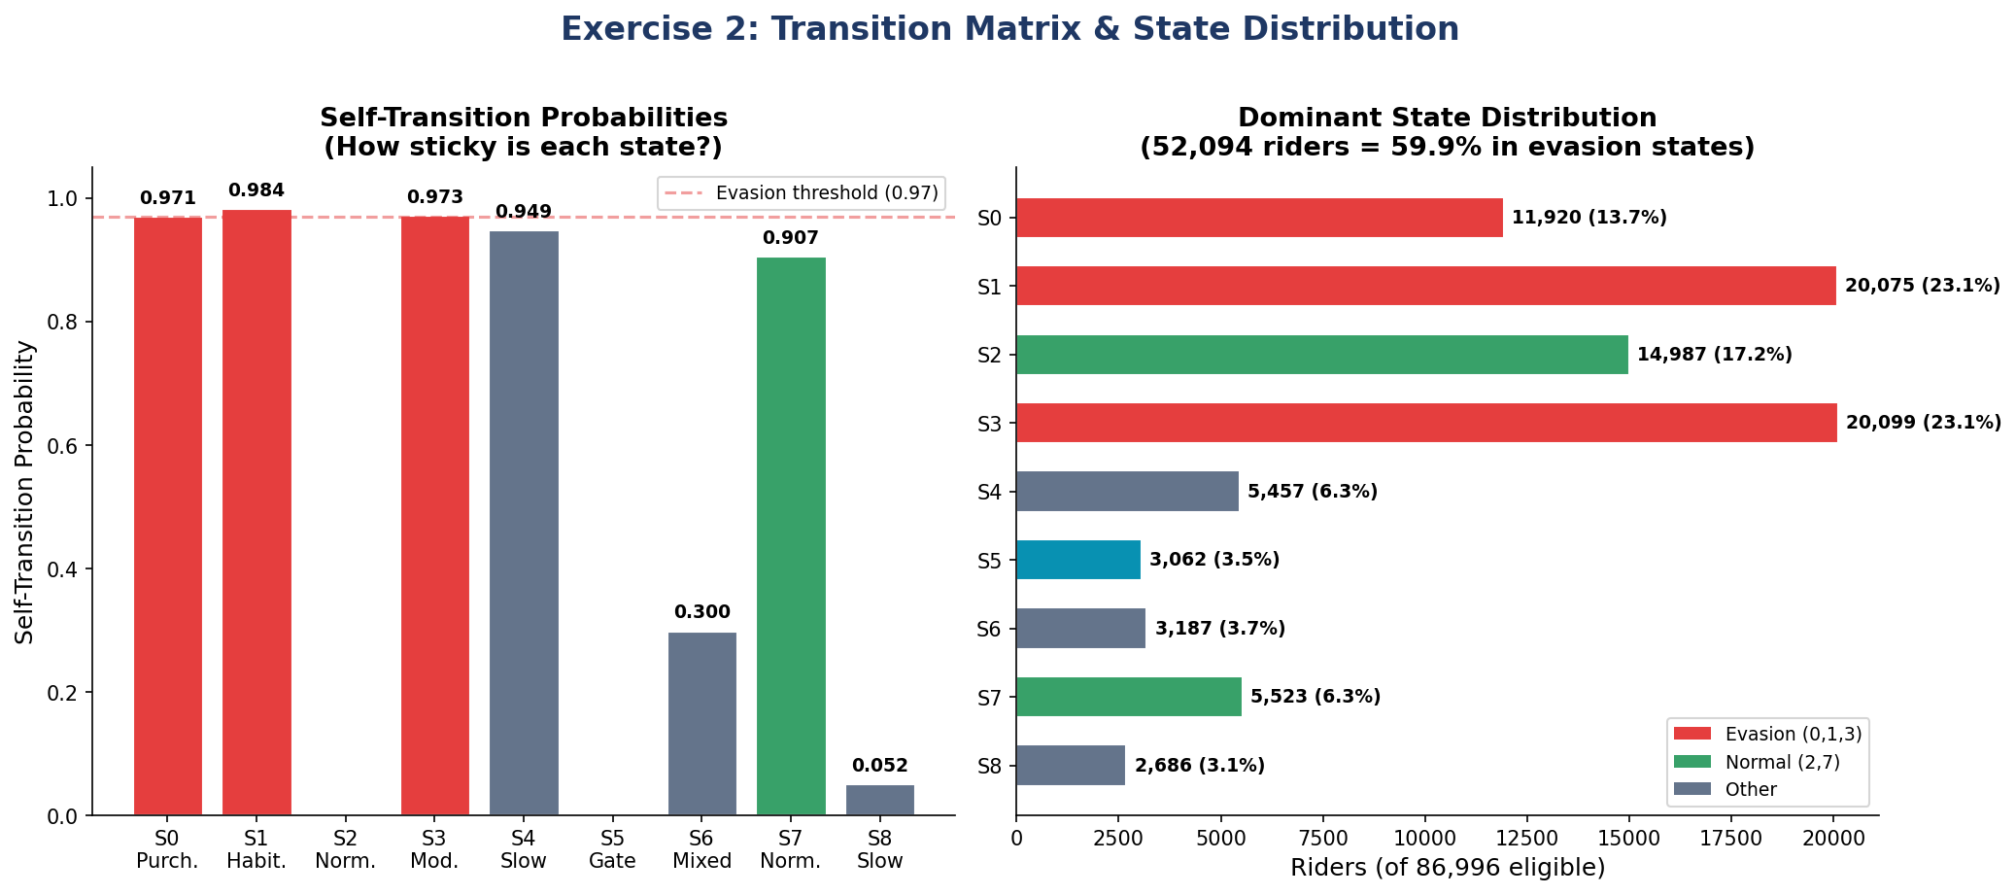
Figure 12. Self-transition probabilities by state (left): States 0, 1, and 3 all exceed the 0.97 evasion threshold (red dashed line), while gate use (S5) and normal-mixed (S2) exhibit zero self-persistence. Dominant state distribution by Viterbi decoding (right): 59.9% of HMM-eligible riders are assigned to an evasion state.

6. Anomaly Scoring, Clustering, and Novelty Analysis
Section 5 established that the HMM identifies three habitual evasion archetypes and produces smooth posterior dominance scores. This section integrates the HMM posterior with three additional signals to produce a composite anomaly score, quantifies the novelty of the resulting flagged population relative to Pattern's existing rules, and segments the suspicious subset into six operationally distinct clusters.

6.1 Composite Anomaly Score
Four normalized signals were combined into a single 0–1 composite score. The weights reflect a deliberate prioritization of signals that are both sharp and resistant to manipulation. Inspector reactivity receives the highest weight (30%) because its theoretical maximum of 1.0 has no innocent explanation. The HMM posterior and the gaming-suspicion score each receive 25%, reflecting their complementary capture of sequence-level and timing-level behavior. Pattern's rule flags retain a 20% weight, ensuring continuity with the existing operational baseline.
Signal | Weight | Mean Contribution | Captures
Inspector reactivity | 30% | 0.0951 | Faster activation under inspection?
HMM posterior | 25% | 0.0560 | Decoded fraction in evasion states?
Gaming suspicion | 25% | 0.0110 | Activations clustered in 16–30 s zone?
Pattern rule flags | 20% | 0.0510 | Existing rule confirmation?

Composite Score Statistic | Value
Mean | 0.2131
Median | 0.1500
Maximum | 0.7887
Riders with score ≥ 0.5 | 25,074 (11.3%)
Riders with score ≥ 0.7 | 411 (0.2%)
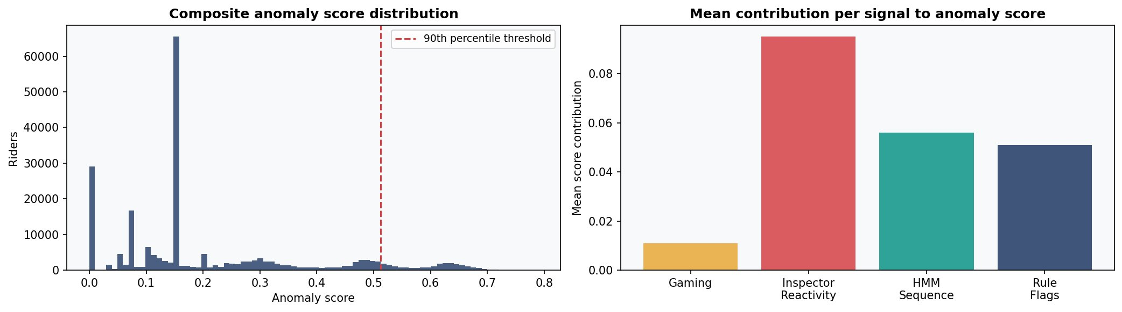
Figure 13. Composite anomaly score distribution across the full 221,382-rider population (left). The 90th-percentile threshold used for selection is overlaid as a red dashed line. Mean signal contribution to the composite score (right): inspector reactivity is the largest contributor, reflecting both its 30% weight and its concentrated distribution in the reactive subpopulation.

6.2 HMM Novelty Analysis
The central success criterion of the project, agreed at inception, was that the pipeline must achieve at least a 20% novelty rate. Novelty is defined as the share of pipeline-flagged riders that Pattern's rules do not flag. The pipeline achieves a novelty rate of 20.5%, exceeding the threshold.
Population Segment | Riders | % of Total
Both HMM + Rules flagged | 40,151 | 18.1%
Rules only (HMM misses) | 18,601 | 8.4%
HMM only (novel) | 15,195 | 6.9%
Neither flagged (clean) | 147,435 | 66.6%

Decomposed to the 15,195 novel riders by dominant HMM state shows that 52.9% are in State 3 (Moderate Evader) and 28.2% are in State 0 (Purchase-Triggered). This is empirically consistent with the structural blind spots of Pattern: the rule engine cannot detect alternation patterns (State 3) or compound purchase events (State 0).
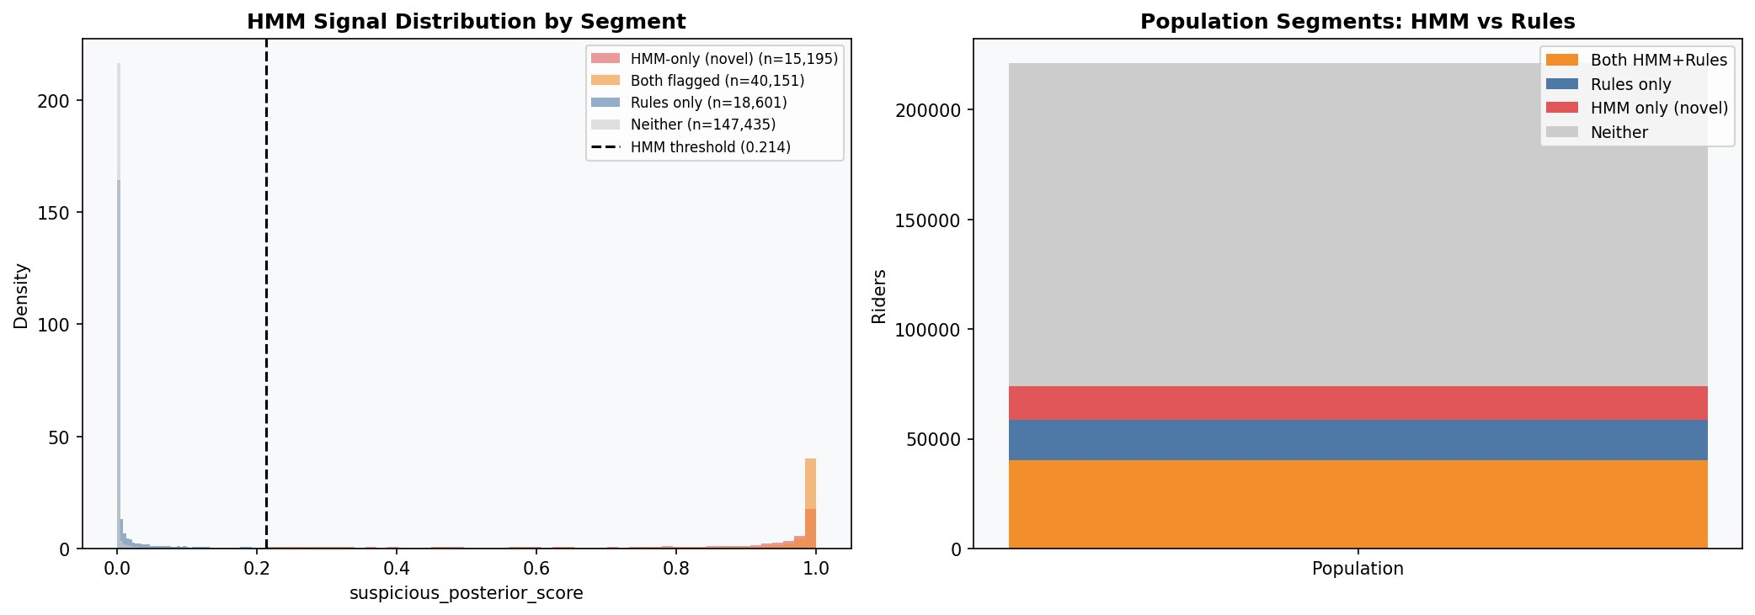
Figure 14. HMM signal distribution by population segment (left). The HMM-only (novel) curve has its mass concentrated at high suspicious-posterior values, confirming that the novel population exhibits genuine HMM evidence of evasion rather than borderline scores. Stacked population breakdown (right): the four mutually exclusive segments — both, rules only, HMM only, and neither — sum to the full 221,382-rider population.

6.3 Anomaly Selection and Tiers
A three-tier selection mechanism produced the 61,869-rider population on which clustering was performed. The tier structure separates riders selected purely on the strength of the HMM signal from those selected by composite-score percentile and from those selected by both criteria simultaneously.
Tier | Riders | Description
hmm_priority | 30,142 | HMM evasion-dominant
hmm_priority_and_score | 21,952 | Both HMM-dominant and high composite score
score_based | 9,775 | High composite score only
Total selected | 61,869 | 27.9% of full population
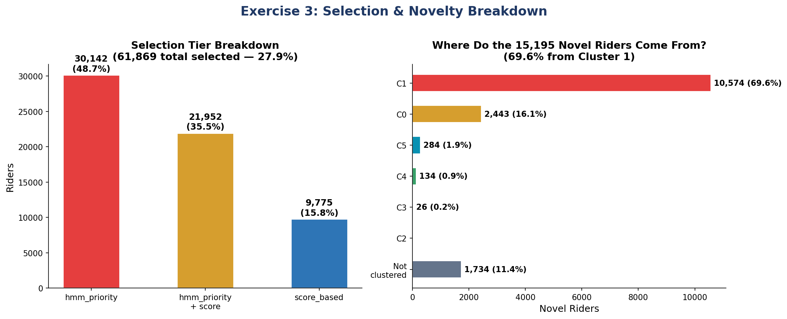
Figure 15. Selection-tier breakdown (left): the 61,869 selected riders distribute across hmm_priority (48.7%), hmm_priority_and_score (35.5%), and score_based (15.8%). Cluster source of the 15,195 novel riders (right): 69.6% originate from Cluster 1 (HMM-Novel Anomaly), providing a single concentrated target for human validation.

6.4 K-Means Clustering
K-means clustering was applied to the 61,869-rider selected subset. Silhouette analysis was performed across K ∈ {4, 5, 6, 7, 8, 9, 10} using the average silhouette coefficient (Rousseeuw, 1987) as the validation metric. The peak occurred at K = 6 with a silhouette score of 0.183, a moderate value that is expected when behaviour lies on a continuous spectrum rather than in well-separated populations. Six clusters were therefore retained.
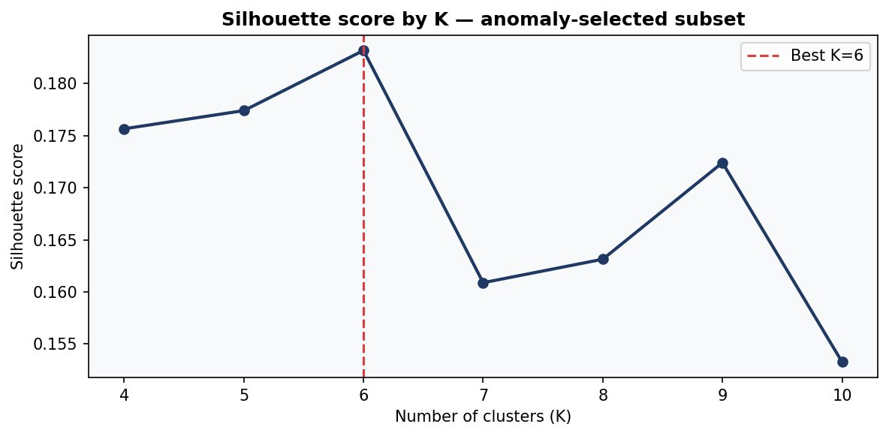
Figure 16. Average silhouette score by number of clusters across the anomaly-selected subset. The score peaks at K = 6 (silhouette = 0.183), with secondary local maxima at K = 5 and K = 9 that fall short of the K = 6 value.

6.5 Cluster Interpretation
ID | Riders | Label | Score | Rule A | Rule B | Susp. %
C0 | 7,136 | Rule-Flagged Evader | 0.416 | 58.9% | 60.1% | 0.798
C1 | 12,606 | HMM-Novel Anomaly | 0.331 | 3.1% | 11.4% | 0.810
C2 | 10,122 | Confirmed Evader | 0.585 | 100% | 100% | 0.909
C3 | 22,199 | Large Evader Pool | 0.534 | 97.6% | 94.0% | 0.942
C4 | 8,644 | HMM-Discordant | 0.399 | 92.2% | 90.7% | 0.249
C5 | 1,162 | Inspector-Reactive | 0.365 | 0.1% | 1.1% | 0.145

ID | Fast 15s | Fast 30s | Mean Gap | Min Gap | Fast Wks | Span | HMM
C0 | 9.9 | 11.7 | 49.6 s | 0.98 s | 79.3% | 82 d | S3
C1 | 3.5 | 4.4 | 54.1 s | 2.10 s | 68.9% | 70 d | S3
C2 | 58.0 | 66.3 | 28.7 s | 0.15 s | 96.2% | 162 d | S1
C3 | 15.1 | 17.8 | 29.0 s | 0.42 s | 88.2% | 100 d | S1
C4 | 14.7 | 19.0 | 117.3 s | 0.89 s | 72.4% | 113 d | S2
C5 | 0.1 | 1.1 | 99.6 s | 20.51 s | 61.1% | 5 d | N/A

ID | Gaming | Inspector | Entropy | Peak % | Line Conc. | Rule Score
C0 | 0.128 | −0.491 | 1.550 | 58.3% | 7.6% | 0.620
C1 | 0.138 | −0.356 | 1.531 | 5.0% | 9.1% | 0.074
C2 | 0.109 | −0.037 | 1.438 | 8.4% | 6.7% | 1.000
C3 | 0.110 | −0.419 | 1.469 | 8.0% | 7.6% | 0.987
C4 | 0.191 | −0.175 | 1.989 | 9.9% | 5.5% | 0.947
C5 | 1.639 | −0.186 | 0.562 | 0.3% | 7.2% | 0.006

6.5.1 Cluster 2: Confirmed Evader (10,122 riders)
Cluster 2 represents the highest priority enforcement target. All 10,122 riders are flagged by both Pattern rules. The mean fast-event count is 58, the minimum gap is 0.15 seconds, the active span is 162 days, and the geographic spread is 29.2 km. Inspector-presence rate is 69.8% and bad-weather rate is 35.1%. Dominant HMM state is S1 (Habitual Evader). Composite score is 0.585 and suspicion percentage is 0.909.

6.5.2 Cluster 3: Large Evader Pool (22,199 riders)
Cluster 3 is the largest cluster and the highest suspicion cluster (0.942). Rule A coverage is 97.6%. Mean fast-event count is 15.1 over a 100-day active span. Inspector-reactivity gap is −0.419 (faster under inspection), and weather gap is −0.566 (faster in bad weather). Dominant HMM state is S1.

6.5.3 Cluster 0: Rule-Flagged Moderate Evader (7,136 riders)
Cluster 0 differs from C2 and C3 in its temporal profile: peak-hour fast events represent 58.3% of activity (versus 8.4% in C2 and 8.0% in C3). Inspector reactivity is the most negative across all clusters at −0.491. Dominant HMM state is S3.

6.5.4 Cluster 1: HMM-Novel Anomaly (12,606 riders)
Cluster 1 is the operationally most consequential cluster from a methodological standpoint. Only 3.1% of its members are flagged by Pattern Rule A, yet 81% are HMM-suspicious and 83.9% are novel under the project definition. Mean fast-event count is 3.5 over a 70-day span, well below Pattern's three-event threshold across most rolling windows. Peak ratio is 5.0%, indicating off-peak evasion. Dominant HMM state is S3.

6.5.5 Cluster 4: HMM-Discordant (8,644 riders)
Cluster 4 is flagged by Pattern at 92.2% but receives a low suspicion percentage (0.249) from the HMM. Mean gap is 117.3 seconds, slow rather than fast, and entropy is the highest across clusters at 1.989, suggesting unpredictable but legitimate behavior. Dominant HMM state is S2 (Normal-Mixed). The cluster is a strong candidate for Pattern false-positive investigation.

6.5.6 Cluster 5: Inspector-Reactive (1,162 riders)
Cluster 5 is the smallest cluster and the most distinctive in feature space. Pattern Rule A flags only 0.1% of its members. Gaming-suspicion score is 1.639, approximately ten times higher than any other cluster. Minimum gap is 20.5 seconds, placing all events in the gaming hot-zone. Geographic spread is 0.0 km, indicating activity at a single station. The cluster represents inspector-reactive activators who would be entirely invisible to the existing rule engine.

6.6 UMAP Visualization
Although K-means clustering was performed in the original feature space, UMAP (McInnes et al., 2018) was used to project the 61,869-rider selected subset into two dimensions for visual inspection of cluster structure. The UMAP figures below confirm that Cluster 5 forms isolated islands — consistent with its distinct gaming signature in feature space — and that the rule-flagged clusters form a connected body.
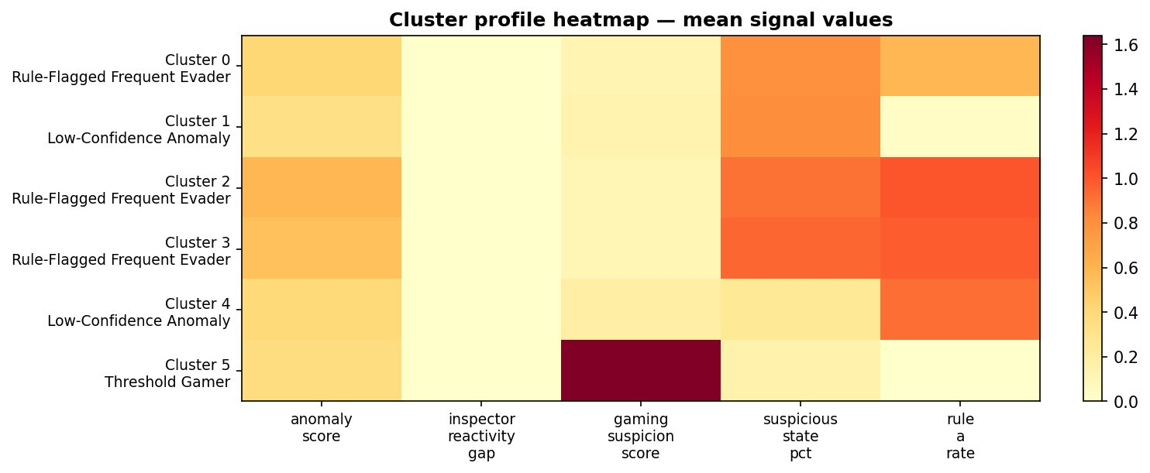
Figure 17. Cluster mean-signal heatmap. Rows correspond to clusters C0–C5 and columns to the five primary signals: anomaly score, inspector reactivity gap, gaming suspicion, suspicious state percentage, and Rule A rate. Cluster 5's gaming suspicion score (1.639) is visibly an order of magnitude greater than any other cluster's value, justifying its operational distinctness despite its small population.
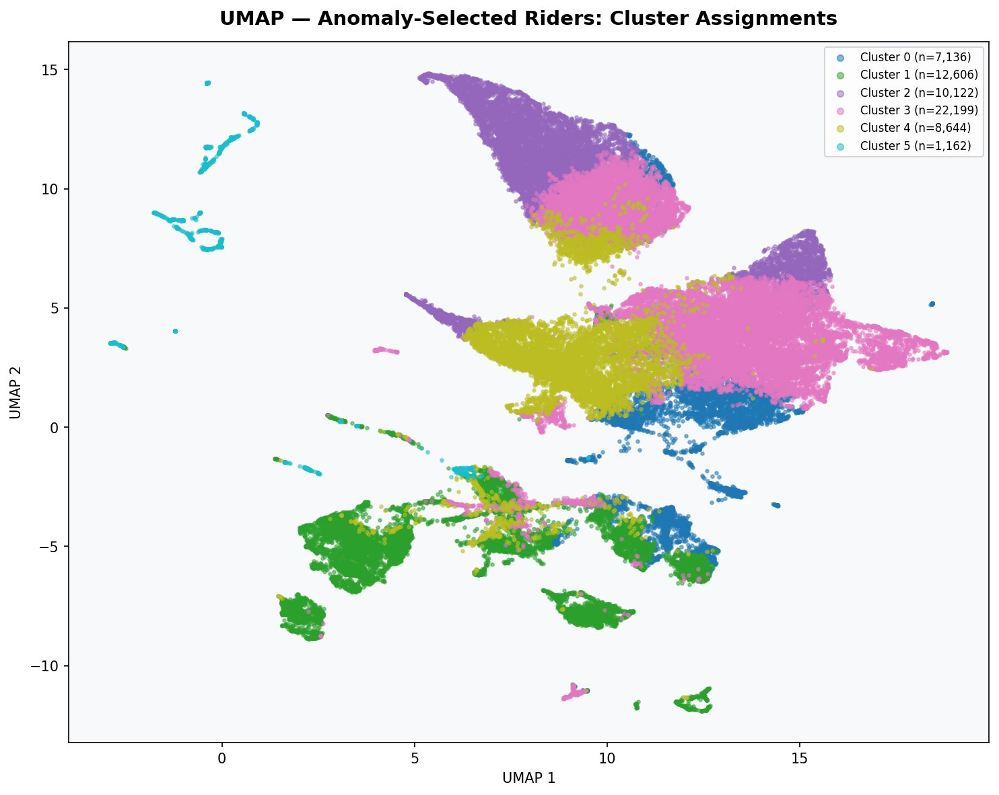
Figure 18. UMAP projection of the 61,869-rider selected subset, coloured by K-means cluster assignment. Cluster 5 (cyan) forms isolated islands at the periphery of the projection, while clusters 0–4 form a connected body in the central mass. The visual structure validates the K = 6 selection.
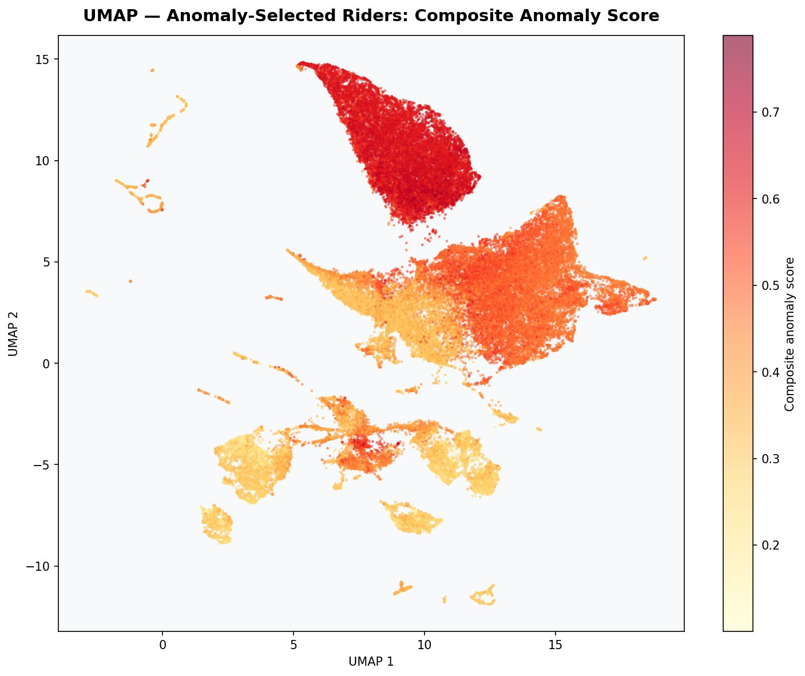
Figure 19. UMAP projection coloured by composite anomaly score. The score gradient flows from yellow (low) through orange to deep red (high), with the highest-scoring riders concentrated in the upper portion of the projection corresponding to Clusters 2 and 3.
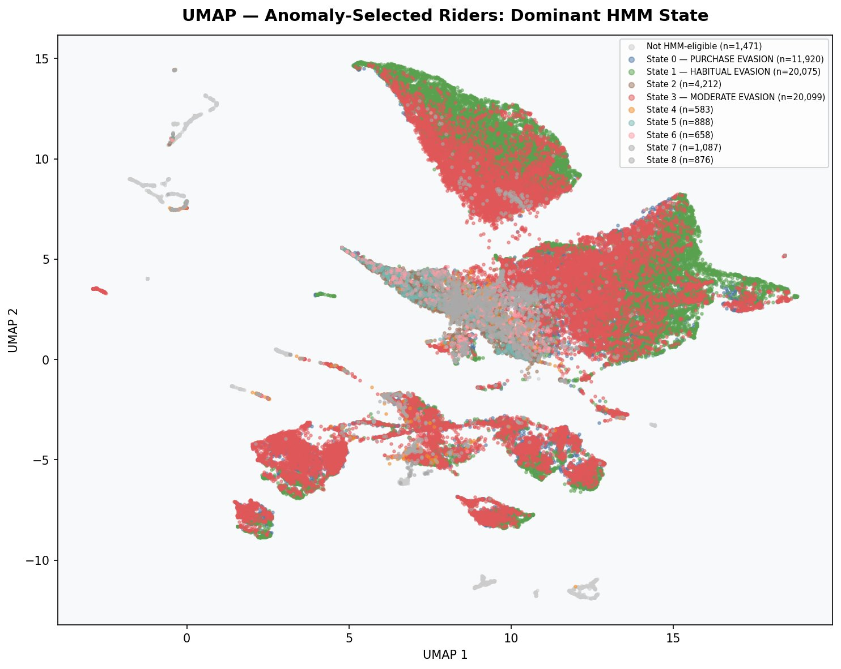
Figure 20. UMAP projection coloured by dominant HMM state. State 1 (green, Habitual Evader) and State 3 (red, Moderate Evader) dominate the central mass and provide the structural backbone of the suspicious population. State 0 (turquoise, Purchase-Triggered) is concentrated in a distinct sub-region.
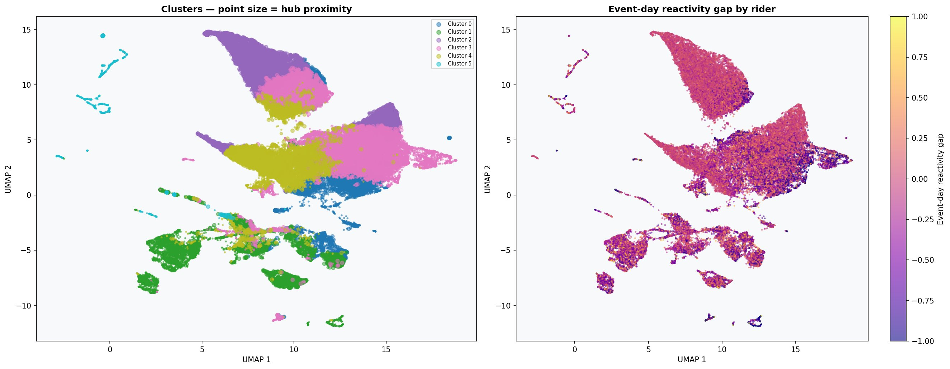
Figure 21. GPS-enriched UMAP visualisation. Left panel: cluster assignments with point size proportional to hub proximity. Right panel: event-day reactivity gap by rider. The gradients confirm that geographic enrichment yields signal coherent with cluster structure rather than orthogonal noise.

6.7 Enriched Cluster Profiles
Geographic, weather, and inspector-context features were appended to the cluster profiles after the initial K-means partition. The enriched profiles reveal substantive between-cluster differences in spatial behavior.
ID | Dist. Hub | Hub Prox. | Geo Spread | Single Line | High Pres. | Weather Gap | Bad Wx
C0 | 8.5 km | 0.226 | 4.1 km | 30.9% | 10.2% | −0.524 | 7.3%
C1 | 7.2 km | 0.166 | 1.5 km | 25.7% | 14.1% | −0.487 | 4.1%
C2 | 17.3 km | 0.504 | 29.2 km | 41.0% | 69.8% | −0.386 | 35.1%
C3 | 11.3 km | 0.335 | 8.9 km | 41.7% | 27.7% | −0.566 | 13.2%
C4 | 13.2 km | 0.268 | 6.4 km | 35.3% | 20.8% | −0.293 | 9.2%
C5 | 3.9 km | 0.043 | 0.0 km | 7.9% | 10.1% | −0.328 | 0.7%
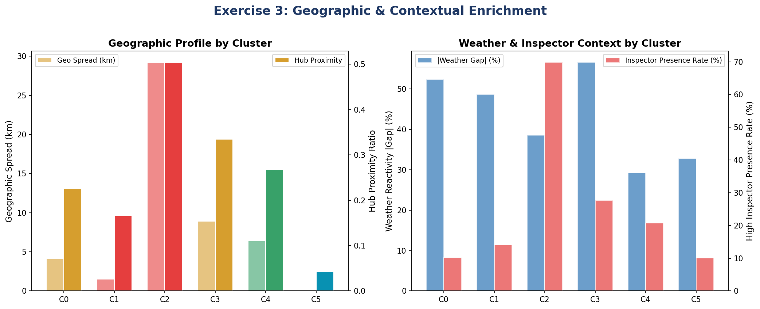
Figure 22. Enriched cluster profiles. Left: geographic spread and hub-proximity ratio by cluster. Cluster 2's 29.2 km spread is dramatically greater than any other cluster's. Right: weather reactivity gap and high-inspector-presence rate. Cluster 2's 69.8% inspector-presence rate is the highest in the dataset and Cluster 5's 0.7% bad-weather rate is the lowest, consistent with their respective behavioural signatures.

6.8 Novel Rider Cluster Decomposition
Cluster | Novel Riders | % of Novel | % of Cluster Novel
C1 — HMM-Novel Anomaly | 10,574 | 69.6% | 83.9%
C0 — Rule-Flagged Moderate | 2,443 | 16.1% | 34.2%
C5 — Inspector-Reactive | 284 | 1.9% | 24.4%
C4 — HMM-Discordant | 134 | 0.9% | 1.6%
C3 — Large Evader Pool | 26 | 0.2% | 0.1%
C2 — Confirmed Evader | 0 | 0% | 0%
Not clustered | 1,734 | 11.4% | —

Cluster 1 contributes 69.6% of the novel population — providing a single, well-defined target for human validation. Cluster 2 contributes zero novel riders, as expected given its 100% Pattern coverage. The 1,734 novel riders not assigned to any cluster were excluded by the clustering step's selection criteria; they remain in the anomaly-scored population for separate review.

7. Discussion

7.1 Answering the Research Questions
RQ1 Inspector-Reactive Behavior:
The inspector_reactivity_gap reaches its theoretical maximum of 1.0 across the top twenty most reactive riders, providing direct empirical confirmation that systematic inspector-triggered activation occurs. Cluster 5 (n = 1,162) is composed almost entirely of such activators, with a Pattern Rule A flag rate of 0.1%, meaning the cluster is essentially invisible to the existing rule engine. The construction of an inspector-presence proxy at vehicle-and-minute granularity provides a transferable methodology for inferring inspection context in any transit system that records handheld-scan timestamps.
RQ2 Sequence Memory:
Sequence-level analysis via the 9-state HMM identifies 52,094 evasion-dominant riders versus the 58,752 flagged by Pattern, with 15,195 of the HMM-flagged riders not appearing in Pattern's set. The three evasion states (S0, S1, S3) all exhibit self-transition probabilities exceeding 0.97 — direct empirical evidence that fare evasion is habitual rather than situational. This finding has substantive operational implications: persistent evaders generate persistent revenue loss, justifying investment in rider-level interventions rather than event-level penalties.
RQ3 Threshold Gaming and Purchase Compression:
Both behaviors are statistically distinct and detectable. Threshold-zone activity concentrates in three timing bands (13–15 s, 16–18 s, 25–30 s) summing to 277,886 events. Purchase compression is captured by the PURCHASE_THEN_ACTIVATE_FAST symbol (≈250,000 events) and is the dominant emission of HMM State 0, which contains 11,920 riders. The terminology 'threshold gaming' is qualified in the report: because MBTA does not enforce the fifteen-second rule (although MTA does), the riders in question are best characterized as inspector-reactive activators. The behavioral signature, however, is statistically real and detectable regardless of the regulatory motivation.
RQ4 Operational Segmentation:
Six clusters emerged from K-means with silhouette validation, each with distinct enforcement implications. Cluster sizes range from 1,162 (C5) to 22,199 (C3), and per-cluster recommendations span immediate enforcement (C2, C3), peak-hour focus (C0), Masabi-led human review (C1), false-positive investigation (C4), and continuous monitoring (C5). The continuous risk score and the discrete cluster label are operationally complementary: the score supports triage and the label supports targeted intervention.

7.2 Pattern versus the Pipeline: A Capability Comparison
Capability | Pattern Rules | ML Pipeline
Riders flagged | 58,752 | 61,869 selected
Scoring method | Binary flag | Continuous 0–1
Purchase-timing detection | None | 3,824 detected
Sequence memory | None | 9-state HMM
Inspector context | None | Train-level (1-min)
Novel riders identified | 0 | 15,195
False-positive identification | None | Cluster 4 (8,644)
Cluster intelligence | None | 6 clusters

7.3 Operational Recommendations
Cluster | Riders | Recommended Action | Rationale
C2 | 10,122 | IMMEDIATE ACTION | 100% Pattern-flagged; 58 fast events per rider; 162-day span
C3 | 22,199 | PRIORITISE REVIEW | 97.6% Rule A; highest suspicion (0.942); largest population
C0 | 7,136 | PEAK-HOUR ENFORCEMENT | 58.3% peak-hour activity; concentrated in rush trains
C1 | 12,606 | MASABI HUMAN REVIEW | 83.9% novel; primary validation target
C4 | 8,644 | FALSE-POSITIVE INVESTIGATION | 92.2% rule-flagged but suspicion 0.249
C5 | 1,162 | MONITOR | Inspector-reactive activators; gaming score 1.639

7.4 The Cohesive Narrative
Five propositions’ summaries the substantive contribution of this work. First, Pattern's rules are necessary but not sufficient: they capture 58,752 riders but leave 15,195 evaders undetected. Second, evasion is habitual rather than situational, as demonstrated by self-transition probabilities exceeding 0.97 across all three evasion states. Third, inspector presence is the sharpest single behavioral signal, with a top-quintile reactivity gap reaching the theoretical maximum of 1.0. Fourth, six operational archetypes drive six distinct enforcement actions, translating continuous risk into deployable intervention. Fifth, validation through the 60-rider review sheet is the critical path that gates the next phase of work; until human-adjudicated labels are returned, all cluster labels are pipeline-generated.

7.5 Methodological Reflections
Three methodological choices warrant brief reflection. First, the decision to retain Pattern's rule flags as a 20% weight in the composite score, rather than to ablate them entirely, is empirically justified by the partial overlap between the rule-flagged and HMM-flagged populations: 40,151 riders are flagged by both systems and treating these as confirmed cases improves operational confidence. Second, the choice of K = 6 for clustering rather than the larger K-values that the silhouette curve also supports was motivated by operational interpretability rather than statistical separability; six clusters can be described, justified, and acted upon, while ten cannot. Third, the unsupervised approach is a deliberate choice — labels were unavailable at project inception — but it imposes ceiling on what can be claimed about precision and recall. The next phase of work, addressed in Section 9, is structured around lifting that ceiling.

8. Limitations
The findings reported in this study are subject to several limitations that should be understood by any reader considering operational deployment of the pipeline.
- Absence of validated labels: All cluster labels are generated by pipelines. The 60-rider Masabi review sheet, the primary validation deliverable, has not yet been returned by domain experts. Until labels are received, claims about precision and recall are not directly testable.
- Stratified training sample: The HMM was trained on a 50/50 stratified sample of rule-flagged versus unflagged riders. This balancing improves discriminative learning but may slightly overrepresent rule-flagged behavior relative to the natural population distribution. The effect on the posterior dominance distribution is not formally quantified.
- Moderate silhouette score: The K = 6 clustering achieves a silhouette of 0.183, which is moderate. This value is expected when behavior lies on a continuous spectrum rather than in well-separated populations, but it implies that some between-cluster boundaries are operational decisions rather than statistical certainties.
- Inferred inspector presence: Inspector presence is inferred from handheld-scan density rather than directly observed via inspector telemetry. The proxy assumes that the 95th-percentile-density bucket corresponds to active inspection, an assumption that is plausible but not validated against ground truth.
- Truncated weather window: Weather enrichment was limited to a six-month window (July–December 2025) due to API rate limits. Weather features are therefore treated as contextual rather than primary, and the weather-reactivity gap should be interpreted as suggestive rather than definitive.
- Unexecuted exercises: Two follow-up exercises, positive-unlabeled (PU) learning and weak supervision, have not yet been executed. Both are described in Section 9 as the immediate continuation of this work.
- Single-agency scope: The study is restricted to MBTA commuter rail. Generalizability to other transit modes (subway, bus) and other agencies (NYCT, BART, TfL) is plausible on theoretical grounds but unproven empirically.

9. Conclusion and Future Work Recommendations

9.1 Conclusion
This capstone has developed and validated a four-layer machine-learning pipeline for behavioral fare-evasion detection on the MBTA commuter rail network. The pipeline complements rather than replaces the existing rule-based fraud-detection engine, retaining Pattern's flags as a 20% weight in the composite anomaly score while extending detection into three previously inaccessible dimensions: behavioral sequence memory via a 9-state Hidden Markov Model, inspector-context awareness via train-level scan-density inference, and continuous risk scoring via a four-signal composite. The pipeline identifies 15,195 evaders that the existing rule engine completely misses (20.5% novelty rate, exceeding the 20% project threshold), surfaces three habitual evasion archetypes with self-transition probabilities exceeding 0.97, and segments the suspicious population into six operationally distinct clusters with tailored enforcement recommendations. All four partner-mandated training adjustments, joblib parallelization, FIFO observation cap, stratified sampling with minimum-event threshold, and posterior dominance scoring, were implemented and validated. The 60-rider enhanced Masabi review sheet has been delivered as the primary validation artefact.

9.2 Future Work Recommendations
Five lines of future work are identified, ordered by immediacy.
- Label acquisition: The Masabi review sheet should be returned with EVADER / NON-EVADER labels at the rider level. This is the critical-path blocker for all subsequent supervised work.
- Positive-unlabeled (PU) learning: Once labels are returned, a PU learning model should be trained using Pattern's rule flags as conservative positive seeds and the HMM-flagged novel population as the unlabeled set. PU learning is well-suited to the asymmetric label structure of fraud detection, where confirmed positives are reliable, but the absence of a flag does not confirm a negative.
- Weak supervision: Five labelling functions are proposed for a Snorkel-style weak-supervision pipeline: inspector-reactivity gap exceeding a threshold, purchase-then-activate-fast count exceeding zero, gaming-zone clustering above a percentile, sequence-persistence in evasion states, and rule-flag confirmation. Weak supervision allows training data to scale beyond the 60-rider human-validated subset.
- New rule for inspector-reactive activators: Cluster 5's statistical signature suggests a candidate new rule for the Pattern engine: flag riders whose minimum gap exceeds 20 seconds, whose fast-event count is below three, and whose gaming-suspicion score exceeds 1.0. Such a rule would close one of the three structural blind spots without requiring full pipeline deployment.
- Cross-agency generalization: The methodology should be tested on a second transit agency, ideally one with different inspection regimes, to assess generalizability. Candidate partners include any Masabi customer agency operating on the Justride platform with comparable telemetry coverage.
The broader contribution of this work is to demonstrate that behavioral sequence modelling, inspector-context inference, and operational clustering can be integrated into a deployable pipeline that materially extends the coverage of existing rule-based fraud detection. The findings are immediately relevant to transit agencies operating mobile-ticketing systems globally, and the methodology should generalize to any fare-evasion detection problem in which activation timing, validation context, and rider-level sequence data are available.

References
Barabino, B., Salis, S., and Useli, B. (2014). Fare evasion in proof-of-payment transit systems: Deriving the optimum inspection level. Transportation Research Part B: Methodological, 70, 1–17.
Bishop, C. M. (2006). Pattern Recognition and Machine Learning. Springer-Verlag, New York.
Chandola, V., Banerjee, A., and Kumar, V. (2009). Anomaly detection: A survey. ACM Computing Surveys, 41(3), Article 15.
Killias, M., Scheidegger, D., and Nordenson, P. (2009). Effects of increasing the certainty of punishment: A field experiment on public transportation. European Journal of Criminology, 6(5), 387–400.
McInnes, L., Healy, J., and Melville, J. (2018). UMAP: Uniform Manifold Approximation and Projection for Dimension Reduction. arXiv:1802.03426.
Phua, C., Lee, V., Smith, K., and Gayler, R. (2010). A comprehensive survey of data mining-based fraud detection research. arXiv:1009.6119.
Rabiner, L. R. (1989). A tutorial on hidden Markov models and selected applications in speech recognition. Proceedings of the IEEE, 77(2), 257–286.
Reddy, A., Kuhls, J., and Lu, A. (2011). Measuring and controlling subway fare evasion: Improving safety and security at New York City Transit Authority. Transportation Research Record, 2216(1), 85–99.
Rousseeuw, P. J. (1987). Silhouettes: A graphical aid to the interpretation and validation of cluster analysis. Journal of Computational and Applied Mathematics, 20, 53–65.
Schwarz, G. (1978). Estimating the dimension of a model. The Annals of Statistics, 6(2), 461–464.
Srivastava, A., Kundu, A., Sural, S., and Majumdar, A. K. (2008). Credit card fraud detection using hidden Markov model. IEEE Transactions on Dependable and Secure Computing, 5(1), 37–48.
West, J., and Bhattacharya, M. (2016). Intelligent financial fraud detection: A comprehensive review. Computers & Security, 57, 47–66.

Appendix A: Pipeline Output Files
All pipeline outputs are reproducible from the codebase. Files are listed in approximate dependency order.
File | Contents
uc2_feature_table.csv | 221,382 × 87 — final rider-level feature table
uc2_event_chain.csv | Full event chain with 7-symbol vocabulary (~500 MB)
uc2_best_hmm_model.pkl | Fitted 9-state CategoricalHMM with metadata
uc2_viterbi_results.csv | 86,996 riders with 9 posterior columns and dominant state
uc2_anomaly_scores.csv | 221,382 riders with composite score and four signal columns
uc2_anomaly_selected.csv | 61,869 selected riders with selection tier
uc2_cluster_assignments.csv | 61,869 riders with K = 6 cluster ID and UMAP coordinates
uc2_cluster_profiles.csv | Six clusters with auto-generated labels and signal means
uc2_enriched_clusters.csv | 61,869 riders with geographic, calendar, and weather features
uc2_hmm_novel_riders.csv | 15,195 HMM-novel riders with cluster assignments
uc2_masabi_review_sheet_enhanced.csv | 60 riders for human validation with event detail
uc2_masabi_review_events.csv | 300 events — top five fastest per validation rider

